**PART B:**

2. What is Boolean? Write down 3 different expression that results a Boolean type

- A Boolean value is either true or false. In Python, the two Boolean values are True and False. A Boolean expression is an expression that evaluates to produce a result which is a Boolean value.

- Three different expression that results a Boolean type:

Ex 1:

>>> 10 >= 3 + 4

True

Ex2:

>>> 11 % 3 == 0

False

Ex3:

>>> type("Hello") == int

False

3. What is a flow chart? Draw flow chart for the following code snippet:

- A flow chart is a graphical representation of a computer program in relation to its sequence of functions (as distinct from the data it processes).

- Draw the flow chart:

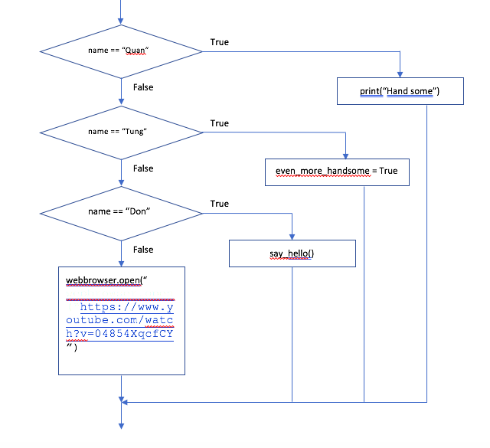

4. What is nested conditionals? Write a piece of code that uses nested conditionals.

- Nested conditionals happen when one condition is nested within another – when a conditional statement is inside a branch of another conditional statement.

- Example:

n = float(input("Student's grade is: "))

if n < 5:

print("fail")

else:

if 5 <= n < 8:

print("average")

else:

print("good")